**Group Members:**

Tirumala Reddy Konireddy

Krishna Chaitanya Nalluri

Syamala Reddy Arimanda

Divya Sree Vintha

Gesture Alerts project  
First Increment Report

**Project Goal and Objectives**

**Motivation**

From last 5 years,the mobile devices are available for every human in the world where we had experienced a lot of innovation in the areas of Health and Fun Applications. But, every mobile application now a days requires eye contact with a mobile, which makes the handicap people having vision impairment can’t utilize the present day technology. We are motivated to make their daily life easy and more entertaining with the present day technology like Android Mobile device and TI sensor tag.

**Significance**

Our Android Application uses the Texas Instruments sensor tag to makes physically challenged people to convey their emotions using gestures easily to the respective persons with ease, also help them to be fit and having some fun.

**Ex:**

It is hard for a vision challenged person to convey as he is hungry to a person related to Dining department who is incharge of his nutrition as he needs to go right to the nutrition in charge and convey about his hunger or atleast type a text message to him.

Our Application will make ease of all this type of problems for vision challenged people using Accelerometer and Temperature sensor.

**Objectives**

* Email or Text alert service for visually changed people Care Taker’s
* Physical Trainer service to help visually changed people be fit
* Sickness Alerts to Care Taker’s and Doctor’s
* Fun activities for Mental relief and Entertainment

**System Features**

* We are providing a Alert service to Care taker’s of visually challenged people by motion gestures related to feeling hunger, need some water, power short circuit etc., through mails or text messages.
* We also provide a physical trainer application which recommends and instructs some fitness programs based on their Body Mass Index. At the end of the workouts session we will provide him a feedback about his exercise.
* We are providing a sickness alert service to physician and doctor in charge regarding the person using temperature sensor.
* We are also providing some entertainment with fun activities for a visually challenged person using TI sensor.

**Activity Recognition Scenario and Data Collection**

**Devices/Sensors:** The CC2541 Sensor tag developed by Texas Instruments is being used to listen or detect the user gestures required for the Application.

This device is capable to detect and send data related to six senses.

* The “IR temperature Sensor” is used to take the body temperature values of users.
* The humidity factor in the environment is detected by the Humidity Sensor.
* The pressure control points are detected by the pressure sensor.
* The device also supports accelerometer data depending on the weight factor experienced by the sensor.
* The Gyroscope feature of this device measures the orientation based on principles of angular momentum.
* The Magnetometer in this device is used to sense the magnetic field and its strength in the surroundings.

This device is enabled with low energy bluetooth data transfer, which is used to collect sensor data sensor tag from Android Mobile device.

**Reference:**

<http://www.ti.com/tool/cc2541dk-sensor?keyMatch=cc2541%20sensor%20tag&tisearch=Search-EN#descriptionArea>

**Data Collection:**

The data is collected from the sensor device which is saved into text files in the mobile device. These files need to upload into HBase for providing Alert service and Fitness work out recommendations. We trigger the necessary service of our application mentioned above related to the change in sensor values data sent by TI sensor tag.

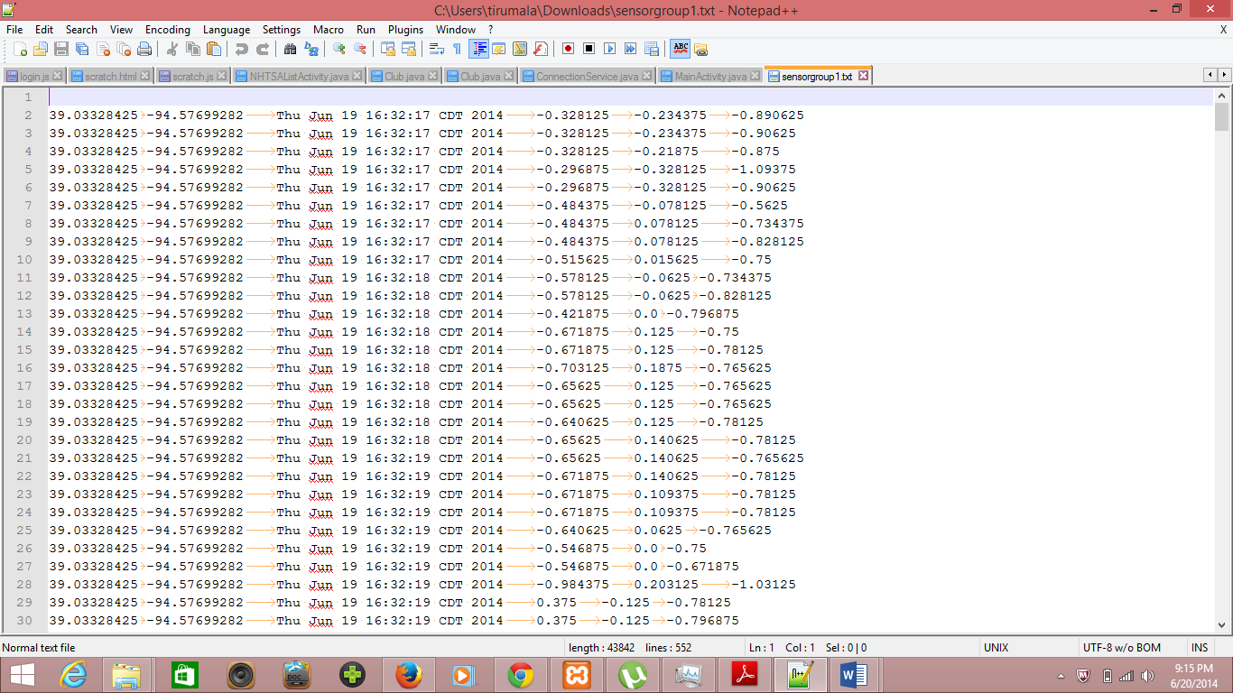

**Motion/Activity Model:**

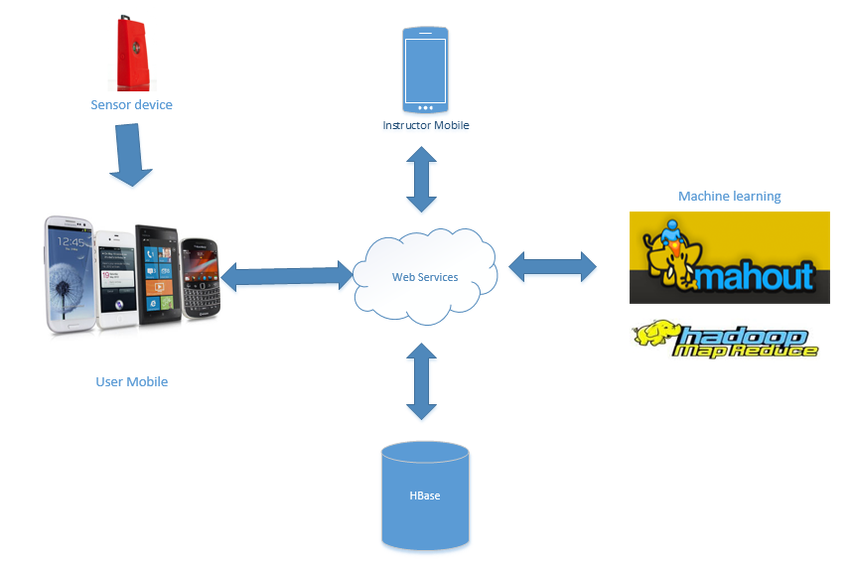

Architecture of the application

**Analytical Tasks:**

* The data is collected from sensor to the mobile as a text log file.
* This log file is automatically uploaded into the HBase using web Service.
* Machine learning algorithms of R / Mahout uses the data in Hbase for providing Alert services and Physical trainer services fro Accelerometer and Temperature data.

**Design of Mobile Client**

**Features, Styles, Technologies, GUI**

* We are providing a Alert service to Care taker’s of visually challenged people by motion gestures related to feeling hunger, need some water, power short circuit etc., through mails or text messages.
* We also provide a physical trainer application which recommends and instructs some fitness programs based on their Body Mass Index. At the end of the workouts session we will provide him a feedback about his exercise.
* We are providing a sickness alert service to physician and doctor in charge regarding the person using temperature sensor.
* We are also providing some entertainment with fun activities for a visually challenged person using TI sensor.

We had planned to work on the GUI from Second Increment.

**Related Work:**

Many speech to text applications are available to store the notes or messages. Our application takes the input using gestures and alerts the trainer with their requirement.

https://play.google.com/store/apps/details?id=com.khymaera.android.listnotefree

The temperature sensor application gives the readings of temperature in specified scales. Our application alerts the user for any unusual temperatures of the user.

https://play.google.com/store/apps/details?id=com.dexterltd.temprature_sensor_lite

**References:**

<http://www.ti.com/tool/cc2541dk-sensor?keyMatch=cc2541%20sensor%20tag&tisearch=Search-EN#descriptionArea>

<http://en.wikipedia.org/wiki/Gyroscope>

<http://en.wikipedia.org/wiki/Magnetometer>

<http://en.wikipedia.org/wiki/Accelerometer>

<https://play.google.com/store/apps/details?id=com.dexterltd.temprature_sensor_lite>

<https://play.google.com/store/apps/details?id=com.khymaera.android.listnotefree>

**Scrumdo:**

We used scrumdo for planning our tasks for this first increment as below.

**Scrumdo Url**

<https://www.scrumdo.com/projects/project/lab-012/iteration/103668>

